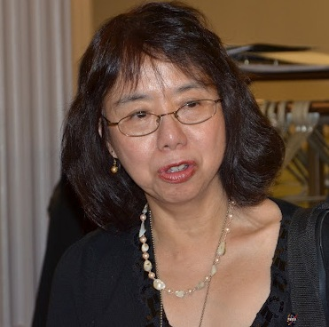
A note on the AAPI Senior Executive Service Kick-Off Event
By Maria So, NASA Goddard Space Flight Center (March 2012)
March 21, 2012 was not a typical day in Washington DC, the capital of our nation. The air temperature was in the low 70s, unusually warm for Washington in the middle of March. The Japanese cherry trees were blossoming a couple of weeks earlier than last year. The traffic was unusually bad on the beltway during the morning rush hours because of the foggy weather. This day was not typical for the Asian American community either because the first Asian American Pacific Islanders (AAPI) Senior Executive Service (SES) Development Program had its kick off meeting. This history making career development program was held at the White House Eisenhower Executive Office Building, a national historic landmark. The Program was initiated and offered by the Asian American Government Executives Network (AAGEN), a volunteer organization comprised of a group of very talented, very capable, and extremely dedicated Asian Americans who donated a lot of time to serving the Asian community. AAGEN launched this SES Development Program to prepare 20 selected candidates, out of 119 applicants, for the highest levels in federal service. This program is organized by AAGEN with support from the White House Initiative on AAPI, Office of Personnel Management, and the Equal Employment Opportunity Commission.
It was not a typical day for me either. I cancelled all my afternoon meetings, took the metro go downtown Washington, and accepted AAGEN’s request to serve as one of the mentors to help this first group of candidates reach the next step of their careers. I was appointed as a SES at NASA Goddard Space Flight Center in 2009. I am the first and still the only Asian female SES at Goddard. Many times during my career I wished I had such a training program to prepare me for the SES responsibilities. I am glad that AAGEN was able to make this training program a reality. I said yes to this invitation because I want to do my share to pass on my experience and my success to others.
During this unusual inaugural event I listened to the welcoming remarks by Tommy Hwang, the Chair of AAGEN. Tommy was selected as a SES directly from private industry without any prior working experience in the government. What an unusual accomplishment! Under his strong leadership and with his passion, Tommy was able to attract many senior executives in the White House, Congress, government agencies, and industry partners to make this training program a reality. Tin Cao, the SES Program Director, devoted many late night hours to organizing this program. I finally could meet face to face with him and thanked him what he has done. Thomas Phan, the AAGEN Executive Director, gave his heart-felt closing remarks that described his “touching dead and standing up in order to stay alive” experience in the concentration camp of Vietnam. I was in tears when I listened to his struggles and again in tears when he described his journey to success. Of course, here was Sharon Wong, my former colleague at NASA and one of the selected candidates. Sharon was our Center’s Diversity and Inclusion Director before she decided to join Office of Personnel Management. She did so much for our Center and because of her leadership, Goddard’s achievement in diversity and inclusion was ranked number one and two among NASA Centers for the last couple of years. Sharon will always be one of us at Goddard no matter of where she is!
When I walked back to the metro station, I thought about all the people whom I just met this afternoon. I could not stop thinking my favorite quote from Theodore von Karman: ”According to all known laws of aerodynamics, a bumble bee can’t possibly fly. The bumble bee doesn’t know this, so he goes ahead and flies anyway.” Are some of us the bumble bee in the quote?
If you wonder why I wrote this note, I was asked repeatedly by Genie Nguyen, one of the AAGEN volunteers, who would not take no for an answer. Thank you Ms. Nguyen for adhering to your duties so diligently!

